EXPERIMENT 20 : PERFORMANCE EVALUATION OF FREE-SPACE OPTICAL
(FSO) LINK UNDER ATMOSPHERIC TURBULENCE USING
OPTISYSTEM

OBJECTIVES :
    - Analyze the effect of range on received power, considering the combined contributions of geometric spreading loss and atmospheric attenuation.
    - Evaluate how the combined effects of increasing range and attenuation influence received power and bit error rate (BER).
    - Assess the extent to which increased transmit power can compensate for attenuation-induced signal loss.

SOFTWARE USED : OPTISYSTEM SOFTWARE

CIRCUIT DIAGRAM:
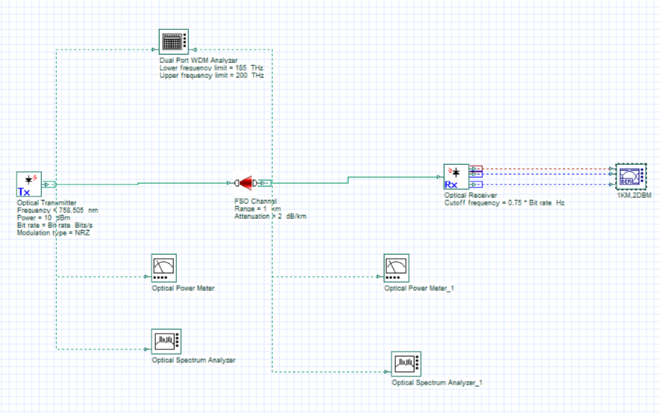

OUTPUTS:
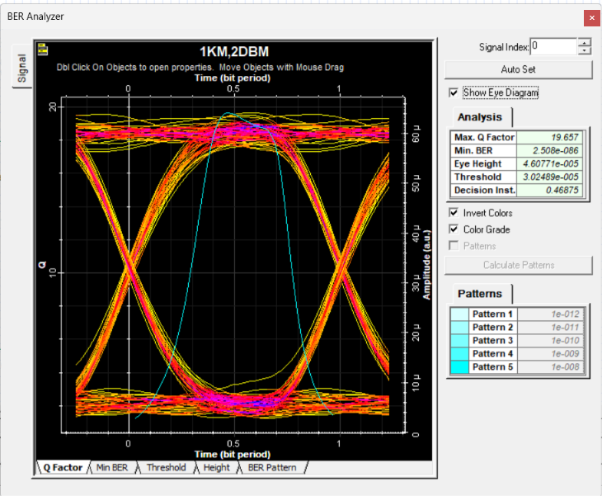 | 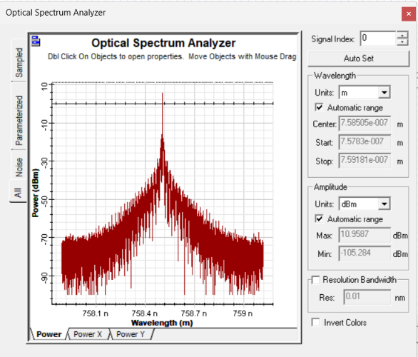
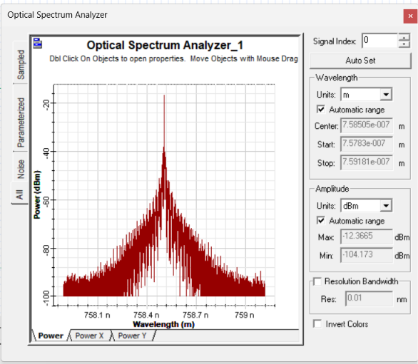 | 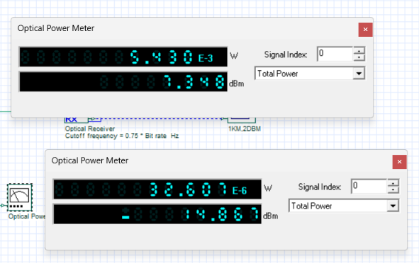
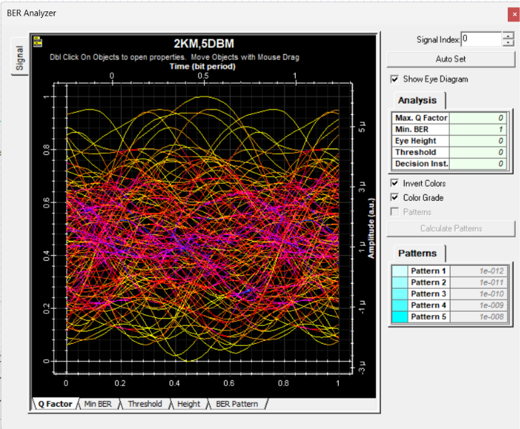 | 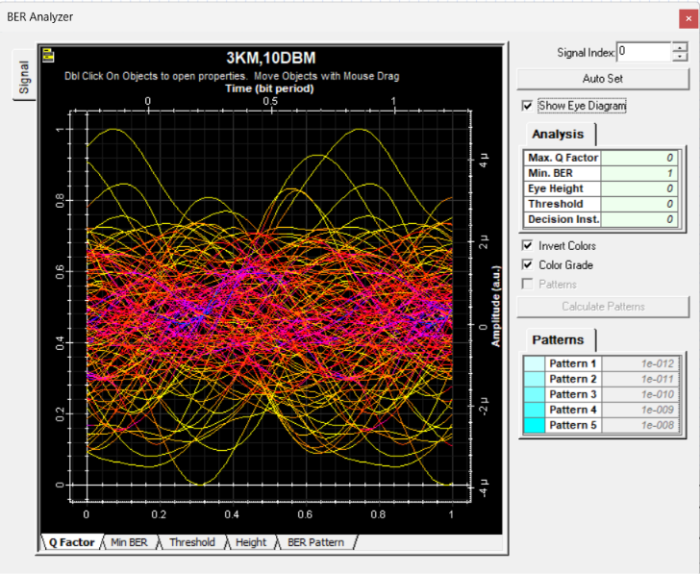

RELFECTION:
I leaned to design and simulate a Free-Space Optical (FSO) communication link using Optisystem and analyze the effects of transmission range and atmospheric attenuation on received power and signal quality.
I understood how geometric spreading and atmospheric losses reduce eye height and affect link reliability , while increased transmit power can partially compensate for signal loss.

RUBRICS:
Objective | Assessment Criterion | Excellent – 4 | Good – 3 | Satisfactory – 2 | Needs  Improvement –  1 | Weighta ge
System  Design &  FSO Link Setup | Correct selection and connection of  OptiSystem components for Free  Space Optics link  (Optical Transmitter,  FSO Channel, PIN  Photodetector, Low  Pass Filter, Optical  Power Meter, Time  Domain Visualizer, BER Analyzer). | All optical transmitter, free space channel,  receiver, and visualizer  components are  correctly selected, connected in  sequence, and  configured without errors. | All  components are present  with minor connection or layout  errors, but  the FSO link remains functional. | Component selection is partially  complete; minor  connection or  configuratio n errors impede optical signal flow. | Incorrect component selection or  improper setup leading to complete  simulation failure. | 20%
Parameter  Configurati on &  Execution | Accurate setup of physical input  parameters:  Wavelength (1550 nm), Modulation  (OOK/NRZ),  Transmit Power, FSO  Range (1 to 15 km), and Atmospheric  Attenuation (2 to 10 dB/km). | All input parameters and test cases across varying ranges and attenuation values are accurately set and executed. | Test case parameters are mostly accurate  with minor setting  discrepancie  s. | Basic parameters are  configured,  but multiple range or  attenuation  test cases are missing. | Incorrect input parameter settings or  failure to run the required  atmospheric test cases. | 20%
Measureme nt & Power  Monitoring | Accurate extraction and recording of  received optical  power, Q-Factor, BER,  Eye Height, and  Threshold across all range settings. | Precise data extraction across all  FSO range cases, neatly tabulated with complete optical  power readings and clear time-domain waveforms. | Data is collected  with minor  omissions in recording  power meter readings, BER, or eye parameters. | Partial data collection with  incomplete  tables or missing optical power  visualizer readings. | Inaccurate, incomplete, or  missing data and  measurements. | 20%
Atmospheri c & Link  Loss  Analysis | Detailed evaluation of geometric spreading loss, atmospheric  attenuation, distancedependent signal  degradation, and  power compensation feasibility. | Comprehensive  analysis correctly  relating range and attenuation  variations to  geometric loss,  received power drop,  eye height reduction, and bit error rate performance. | Clear analysis  identifying  basic trends in received power and eye height  relative to  FSO  distance. | Basic attempt at result  analysis without  explaining physical  mechanisms  like  atmospheric scattering or geometric loss. | Erroneous or missing analysis  of simulation results and  power meter outputs. | 20%
Report & Conclusion | Identification of maximum reliable communication  distance, power  compensation trade-  offs with diminishing returns, and structural clarity. | Report features clear time-domain  waveforms, complete power tables, and insightful  conclusions  identifying optimal operational  parameters under atmospheric impairments. | Satisfactory report with relevant  visualizer  displays and sound  concluding summary. | Incomplete report with  missing graphs,  power  readings, or weak  conclusions. | Disorganized or incomplete  report lacking required  diagrams and valid  conclusions. | 20%

CONCLUSION:
The simulation in OptiSystem provides a clear understanding of how FSO systems perform under varying ranges and atmospheric conditions. This analysis helps design robust FSO systems for different applications, ensuring reliable performance in various environments.

